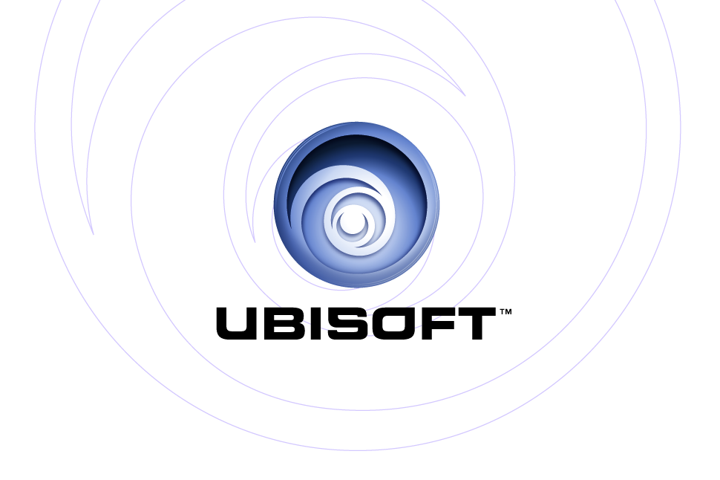
PRESENTS: | PlayStation®2
 | Xbox®
AND 1® STREETBALL

Product Description
When you ball, you know you’re not going to do some fancy 360 with 30 flips in the air and dunk from half-court. When you talk about playing streetball, you keep it real. You bring crowds to their feet by dropping shiny no-look dimes to your teammates. You go strong to the rack and bang on fools no matter how many try to stop you. And when you’ve got it all, you paint pictures on backboards by pinning your opponent’s shots. But it’s not until you showcase your own original moves and signature style on the world’s toughest playgrounds that you get your name mentioned alongside Skip-To-My-Lou, AO, Hot Sauce, The Professor, and other streetball legends. We may speak the same language, but don’t ever say it’s the same game. AND 1 Streetball…true to the game.

Key Features

- Step into the shoes of AND 1 players: Execute mesmerizing moves like Hot Sauce’s killer crossovers, Helicopter’s rim-bending dunks and The Professor’s no-look passes.

- Become the next AND 1 legend: Story mode allows you to experience the trials and exhilarations of getting signed to the AND 1 MixTape Team, as seen on ESPN. Dominate the Open Run, survive the hazing, and bring it home in the Final Game.

- Revolutionary “Create-A-Move” editor: Build your own character and create your own signature moves using the AND 1 Create-a-Move editor, loaded with custom showboating, scoring and celebration moves.

- Can you handle it? School the competition with I-Ball Controls, an intuitive control system that gives you fluid and precise command over every offensive and defensive move. Not only will you do it, you will also feel it.

- Run it how you want it: Play the game you want to play. Scale your teams anywhere between one-on-one to a full team of fives. Run a full-court game, or do a half-court battle – the choice is yours.

- Heavy rotation – station identification: Music soundtrack features a loaded and customizable library of exclusive tracks from various regions. West Coast, East Coast, the Dirty South and more. Each court has its own sound and flavor.

- Online multiplayer: Put your skills to the test against other top players as you showcase your own creative moves and strive to gain a reputation as the best.

Product Specifications:
Publisher: Ubisoft
Developer: BlackOps
Ship Date: Winter 2005
Category: Sports
Rating: “RP” (Rating Pending)

© 2005 Ubisoft Entertainment. All Rights Reserved. AND 1® and Mix Tape® are trademarks of AND 1. Ubisoft and the Ubisoft logo are trademarks of Ubisoft Entertainment in the U.S. and/or other countries. Microsoft, Xbox, Xbox Live, the Live logo and the Xbox Logos are registered trademarks or trademarks of Microsoft Corporation in the United States and/or in other countries and are used under license from Microsoft. This title has not been officially concept approved by Sony Computer Entertainment America.

