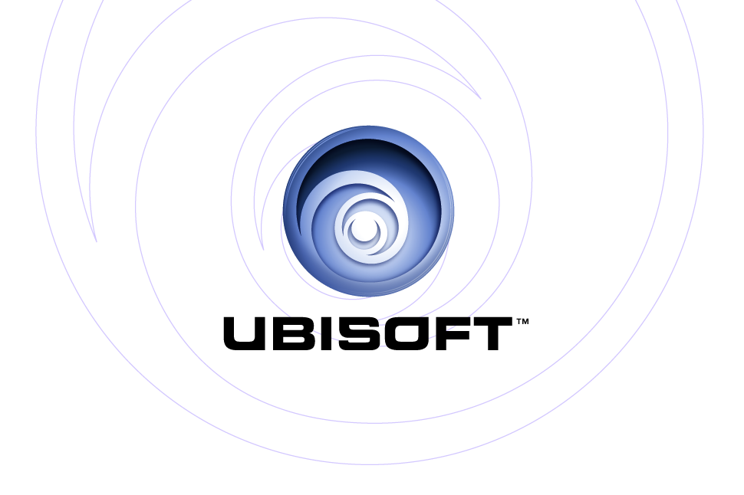
PRESENTS: | PlayStation®2, Xbox®

Tom Clancy’s Rainbow Six Lockdown

Product Description

In the near future, terror has escalated to a new level: bioterrorism. A global terrorist network threatens to strike with a terrifying nanotech virus – but the target is uncertain. Team Rainbow, an elite counter-terrorism unit, is spearheading a new war on terror. They are the only ones who can save millions of innocent lives threatened by radical terrorists.

But when Team Rainbow is personally attacked, close-quarter battles reach unprecedented levels of tension and intensity. They will do whatever it takes to protect their people and bring then home. Team Rainbow does not negotiate with terror. They destroy it.

Key Features

- Lead Team Rainbow, a deadly counter-terrorism unit comprised of the world's best operatives, equipped with the latest weaponry.

- Immerse yourself in tense close-quarter combat, where split-second decisions mean the difference between life and death

- Thrilling single-player campaign with dual perspective gameplay has you playing as Ding Chavez, the confident team leader who never leaves a man behind, or as Dieter Weber, the team's arrogant, relentless sniper who never misses a target.

- Tension-building sound effects (creaking floorboards, whispers and hostages begging for their lives) hint at a threat around every corner.

- New weapons & equipment – Complete your mission with all of the tools of the trade including new items like motion trackers, battering rams, and the deadly MTAR-21 micro assault rifle.

- Increasingly intelligent enemy A.I. where, with every mission, enemies get more dangerous using tactics like flanking, suppression fire and room clearing.

- Stunning graphics and ultra-realistic "ragdoll physics" deliver staggering realism and spectacular close quarter firefights. Rainbow Six is pushing the limits of PlayStation 2 and will be the best-looking military shooter on the market.
- Superior multiplayer experience – One of the best multiplayer games ever returns with a revolutionary multiplayer experience on the PlayStation 2 and Xbox Live.
  - Xbox: The innovative Persistent Elite Creation Mode allows players to create their own operative, improve its’ skills, and acquire extra equipment in all-new objective-based missions.

  - PS2: New Rivalry mode pits Rainbow operatives against trained mercenaries in objective-driven team-based adversarial gameplay.

Product Specifications:
Publisher: Ubisoft
Developer: Red Storm Entertainment (PS2) and Ubisoft’s Montreal Studio (Xbox)
Release Date: Summer 2005
Category: First Person Shooter
PEGI: 16+

