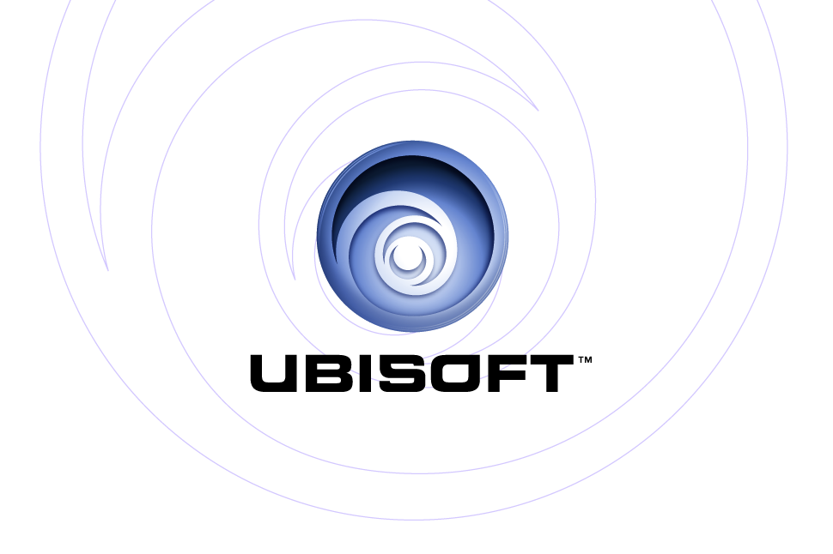

ACTORS ARE BACK, IN MYST IV REVELATION

Ubisoft has taken on the young actress Juliette Gosselin to play the role of Yeesha, the heroine of the new episode of Myst.

Paris (France), 28 June 2004 – Ubisoft has taken on the young actress Juliette Gosselin (aged 13) to play the role of Yeesha, the daughter of Atrus, in the new episode of Myst.

Yeesha is a very pretty 10-year-old girl, who is advanced for her age. Filled with wonder at all the forms of natural life she encounters in the adventure, she is responsible and headstrong, sometimes to her own cost. She is abducted by her brothers and destined for a tragic fate. Nevertheless, she constantly attempts to reunite her family. Will her compassion and her extraordinary maturity triumph over the resentment and dangers that lie in wait for her?

Juliette “Yeesha” Gosselin, a young Quebecker, has just finished shooting the movie “Nouvelle-France” with Gérard Depardieu. “I learned a lot when shooting Myst IV Revelation, but I was surprised to see how different it is to act in a game,” Julie told us. “It’s very difficult to communicate your emotions on the spur of the moment when you’re thinking about the final result! There are so many special effects you have to consider!”

Rand Miller, creator of the saga, again takes on the role of Atrus – the father of the disunited family – while the two accursed sons, Sirrus and Achenar, are played by Brian Wrench and Guy Sprung.

Myst IV Revelation has more than 90 minutes of real acting, directly incorporated into the adventure.

Myst IV Revelation is better looking and more intense than ever! It will unveil terrible secrets and, in the end, reveal the truth. The technical means that were mobilized to create this episode are what could be described as “unconventional” in the video game industry. It took three and a half years for a team of 80 talented individuals – working relentlessly in Montreal – to produce, in September, this sublime piece of work, which, more than ever, is well within the reach of the general public.

About Ubisoft:

Ubisoft is a worldwide producer and publisher of interactive games. The group is the leader of its field, offering a varied and constantly increasing range of products. Ubisoft develops its own products and also teams up with well-known developers. The group’s ambition is to offer the public games of outstanding quality, with strong emotions for all to share. Created in 1986, Ubisoft does business in 21 countries, including the United States, Canada, Germany, France and China. The group distributes its products and third-party products in more than 50 countries. In the 2003-2004 financial year, its turnover reached 508 million euros, up 12.5% on the previous year. For more information: www.ubi.com

© 2004 Ubisoft Entertainment. All Rights Reserved. Ubisoft, ubi.com, and the Ubisoft logo are trademarks of Ubisoft Entertainment in the U.S. and/or other countries. D’niTM, Cyan®, and Myst® are trademarks of Cyan, Inc. and Cyan Worlds, Inc. under license to Ubisoft Entertainment.


Press Contact
Emmanuel Carre

ecarre@ubisoft.fr

Telephone: 00 33 (0)1 48 18 50 91

