Myst IV Revelation – Faster & user-friendly navigation using the zipmode

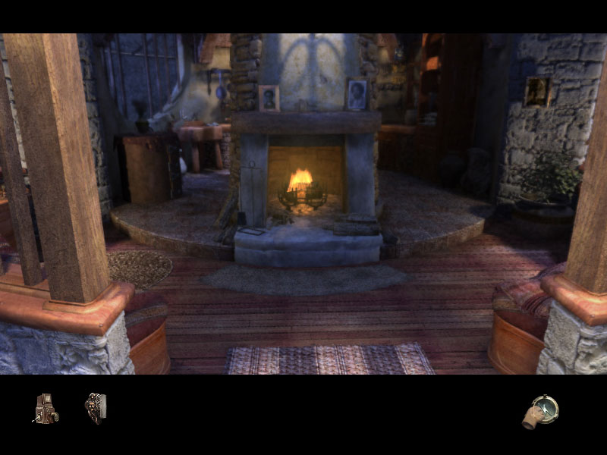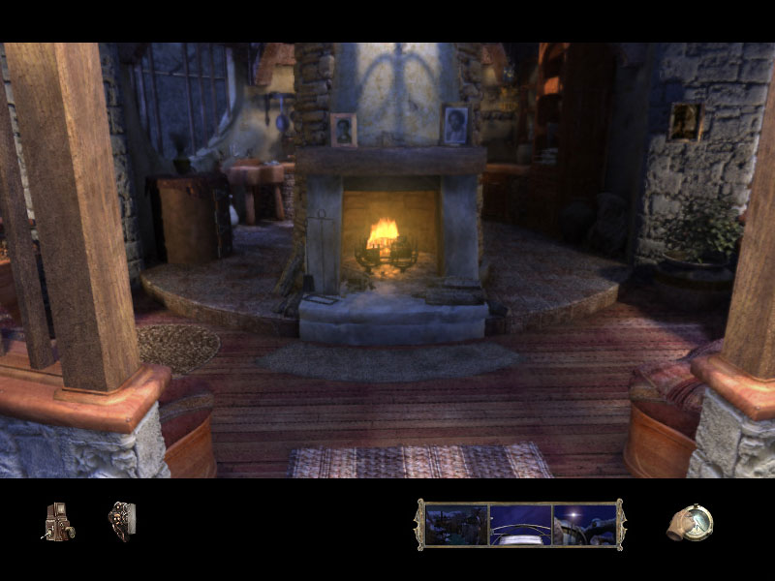

1. Activate the zipmode 2. The zipmode function appears

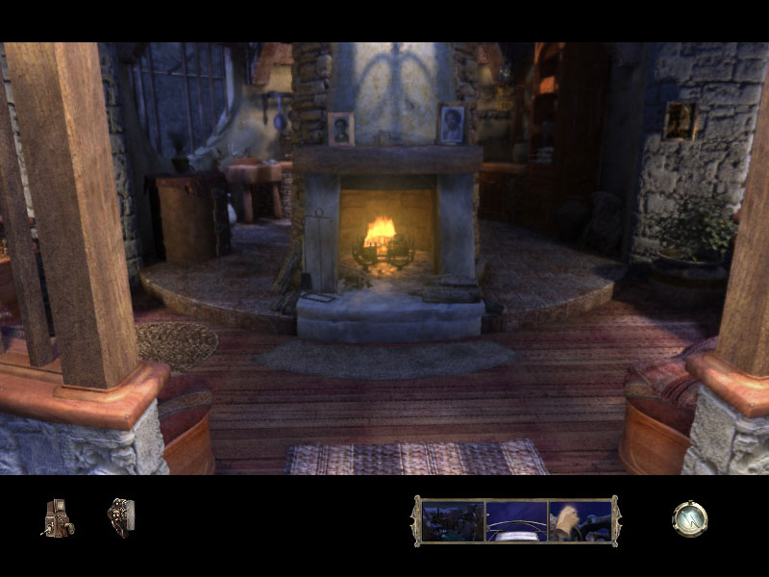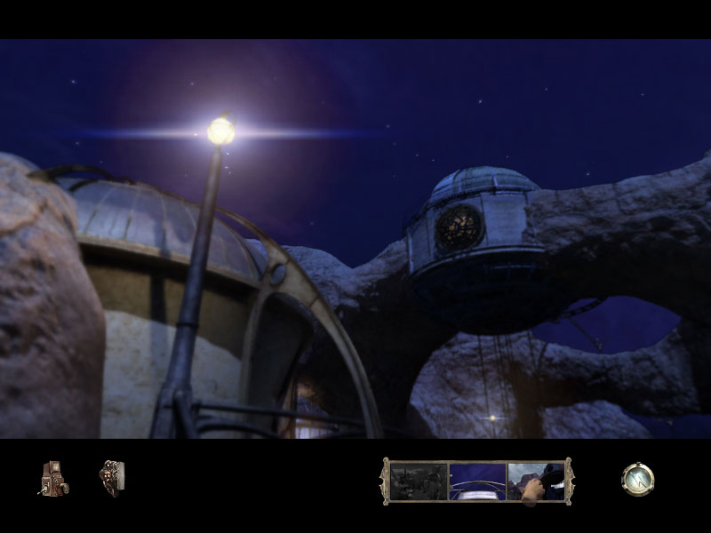

3. Choose the place where you’d like to return 4. You’re back to the place you wanted to re-visit

