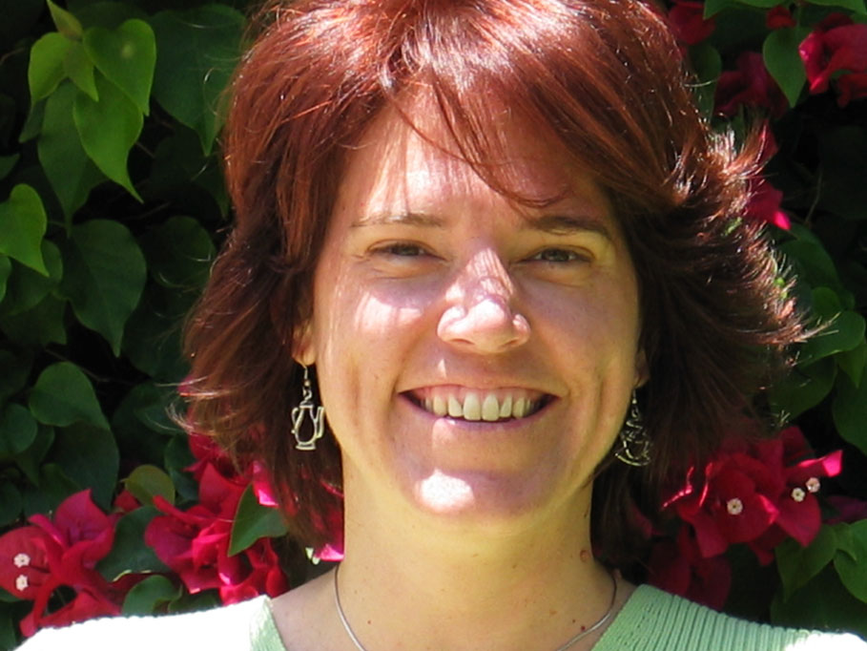

Mary De Marle
Writer

Mary De Marle brings a wealth of experience to her role as Writer-Designer for Myst IV: Revelation. She began her career in Los Angeles in 1987, after first receiving a Bachelors of Science degree in Television, Radio, and Film from Syracuse University. In Los Angeles, De Marle worked behind the scenes on such television and film fare as Stephen J. Cannell’s “Hunter” and Newline Cinema’s NIGHTMARE ON ELM STREET, PART IV.

In the spring of 1990, De Marle was hired by Hanna-Barbera, Inc., the cartoon studio responsible for creating “The Flintstones.” She spent four years working as Creative Director for the studio’s marketing and licensing divisions, before turning to freelance writing as a fulltime endeavor. From 1994 to 1998, DeMarle’s clients included many entertainment industry stalwarts, including 20th Century Fox and Universal Studios.

Yet the lure of writing science fiction and fantasy was something the writer could not deny. So, in 1998, De Marle teamed up with San Diego-based computer game developer Presto Studios to design and write the third instalment of the popular computer game, MYST. Released in 2001 by Ubisoft Entertainment, MYST III: EXILE was nominated for outstanding story design by the Academy of Interactive Arts and Sciences (AIAS), and has since sold more than a million copies worldwide.

In November of 2001, De Marle joined Ubisoft Montreal as a freelance writer-designer on MYST IV: REVELATION. Prior to working on that game, however, she also teamed up with Vancouver-based game developer Relic Entertainment to write a sequel to their best-selling strategy game, HOMEWORLD. Released in 2003 by Sierra Entertainment, HOMEWORLD 2 has received high accolades for its engrossing single-player story, and in 2004 was named as an AIAS finalist for Strategy Game of the Year.

Now that her work on MYST IV is finished, De Marle is devoted to completing her own science-fiction novels and short stories. She continues to freelance for the game industry today, and looks forward to many successful projects to come.

