

Pascal Blanché
Art Director, Lead character designer; Myst® IV: Revelation

1) Can you tell us a little about yourself, and your job on Myst® IV: Revelation as an Art Director?

Pascal Blanché : My main task is to define each process of creating graphics in Myst, and lead all the artists in the same direction. Meanwhile I am also responsible for validating the graphic quality and the designs of each object of Myst. Prior to working on Myst, I was Senior Animator on the computer graphics animated movie “Kaena: The Prophecy”.

2) Can you explain the ALIVE technology? How do they mix pre-rendered + real time 3D + live action?

Pascal Blanché : The ALIVE technology (Advanced Living Interactive Video Environment) is a collection of technological breakthroughs that come together to give us totally living, breathing environments. We have a technology that makes the clouds move, another to make the water interactive, another to generate particles for fog, smoke, small flies and other things. We have lighting technology (lightsets) to turn lamps on & off, we can generate beams of light in 3D, we can have the shadow of the clouds dance over the background and change the intensity of the general lighting in real-time. Then, we also have the panel technology allowing us to display video anywhere we want on the screen. This allows us to integrate live-actors or 3D-animals, and they can seamlessly travel across the environment. All of these things are used differently in each of the environments of the game in order to create the appropriate moods we are looking for. People are usually very surprised when they see the game, they don’t understand how it can move like that and NOT be all in real-time 3D.

3) You can see a tendency in games where graphics get better and better but there is almost no innovation in gameplay. Do you think Myst IV: Revelation makes a difference? If yes, how?

Pascal Blanché : Well, obviously graphics are very important in a game like Myst, but the difference we tried to focus on in Revelation was to really make you feel present in the different worlds you explore. There are all kinds of little things that were put in to remind players that they have a physical presence in the world. They can hear their footsteps when they turn around, they can touch all the objects close to them (and hear the sound associated to each one), they can interact with many things; characters will sometimes react to some of their past actions; they can interact (ie, communicate) with some creatures, etc. So it really changes a player’s relationship with the game world and that’s how we can create the kind of memorable experience we are looking for.
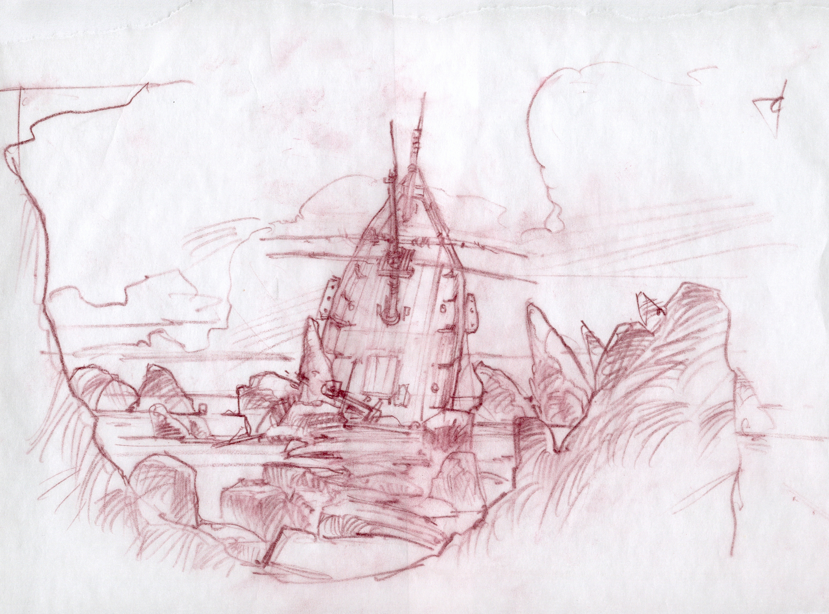
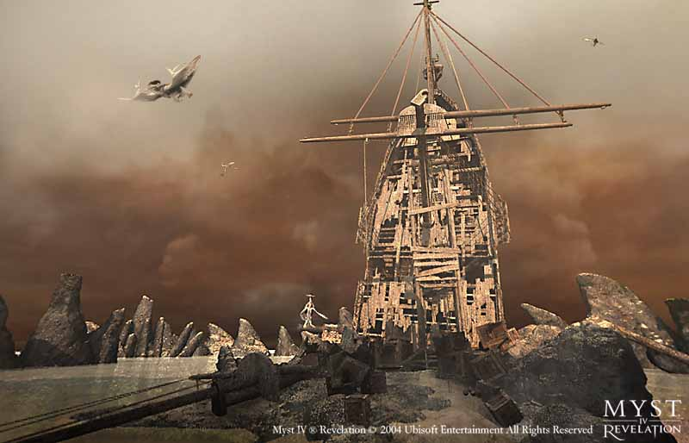
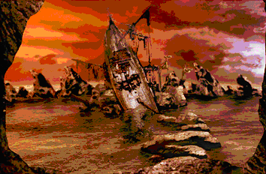

4) Could you tell us a bit more on the creative process, regarding the animals’ creation for example?
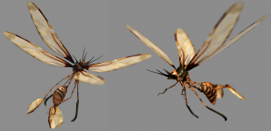
Pascal Blanché : We tried to create an environment as rich, original
and alive as possible for the players. By creating animals that seem
familiar, we are able to create an atmosphere and immerse the
player in a world as beautiful and realistic as possible. We really
want the player to feel a part of this world. For example, we have
little insects, which are a tiny part of the wildlife you will discover
in one of the ages of Myst Revelation.
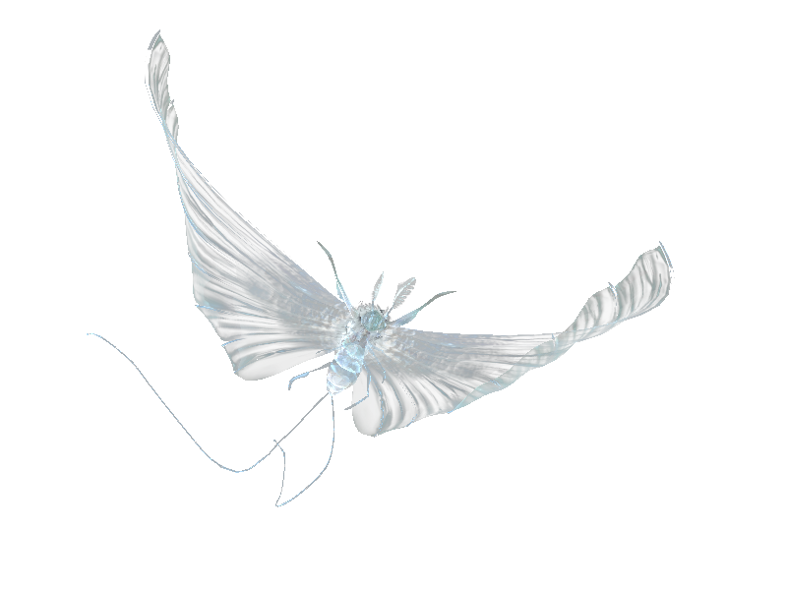

For the main design of such elements, I usually start from real animals that we
can see on earth and start to twist them a bit, to make them look more from
another world. But still, you are able to figure out what kind of creature you are
dealing with, which I think makes the game more realistic. To come back to
the insects, one of our designers (Tania) found her inspiration for the wings in
an art book called: “Victorian fairy painting”. I was there to guide her and help
her develop her creation.
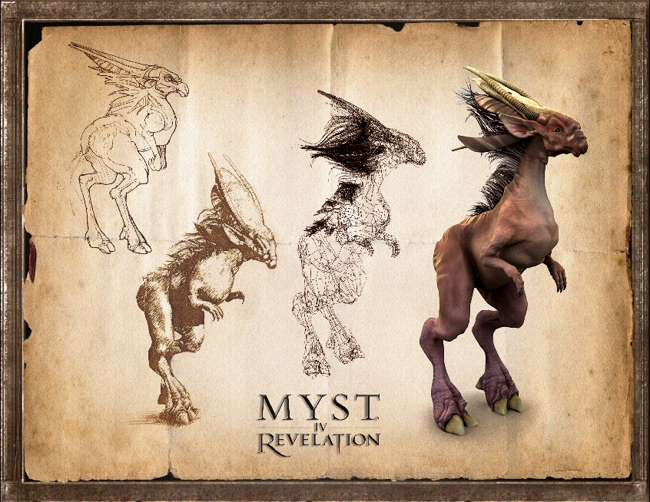

Big animals in Myst Revelation are part of the backstory and game
design structure. We had to pay attention to every detail in the creation
process to make sure that the game design intentions were clear
enough in the final model. The one you can see on these sketches
is an herbivore called “zeftyre”. It’s a friendly peaceful creature that
lives in a swamp but it doesn’t like to get disturbed! It was created by
mixing an antelope and an ostrich. You can also interact with the
herbivores in their environments.

If you want to see the herbivores in the Age they belong to, take a
look at the picture that won the “Into the pixel contest” at E3.
It is called “The Swamp” by Olivier Leonardi.
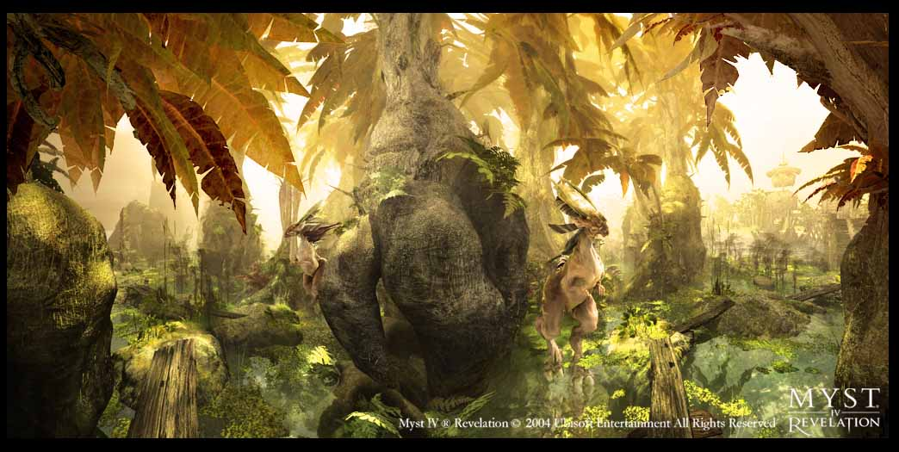

5) Can you tell me more about that first prize you won at the Into the Pixel @ E3
graphic competition?

Pascal Blanché : Olivier Leonardi, one of the lead artists of the team, was in charge of this area. It is exactly the kind of locations that perfectly reflects the attention the artists gave to details.
But the most impressive thing is actually to see it in the real game, with all those animations and effects bringing these great graphics to life.

6) Is it true that the game will only be released on a dvd?

Pascal Blanché : Yes, Myst Revelation is released on DVDs, otherwise it would have been 9 or 10 cds and that would just have been a nightmare for players to manage. We felt DVD drives have reached a penetration point and a price range that make them the best solution for our game.

