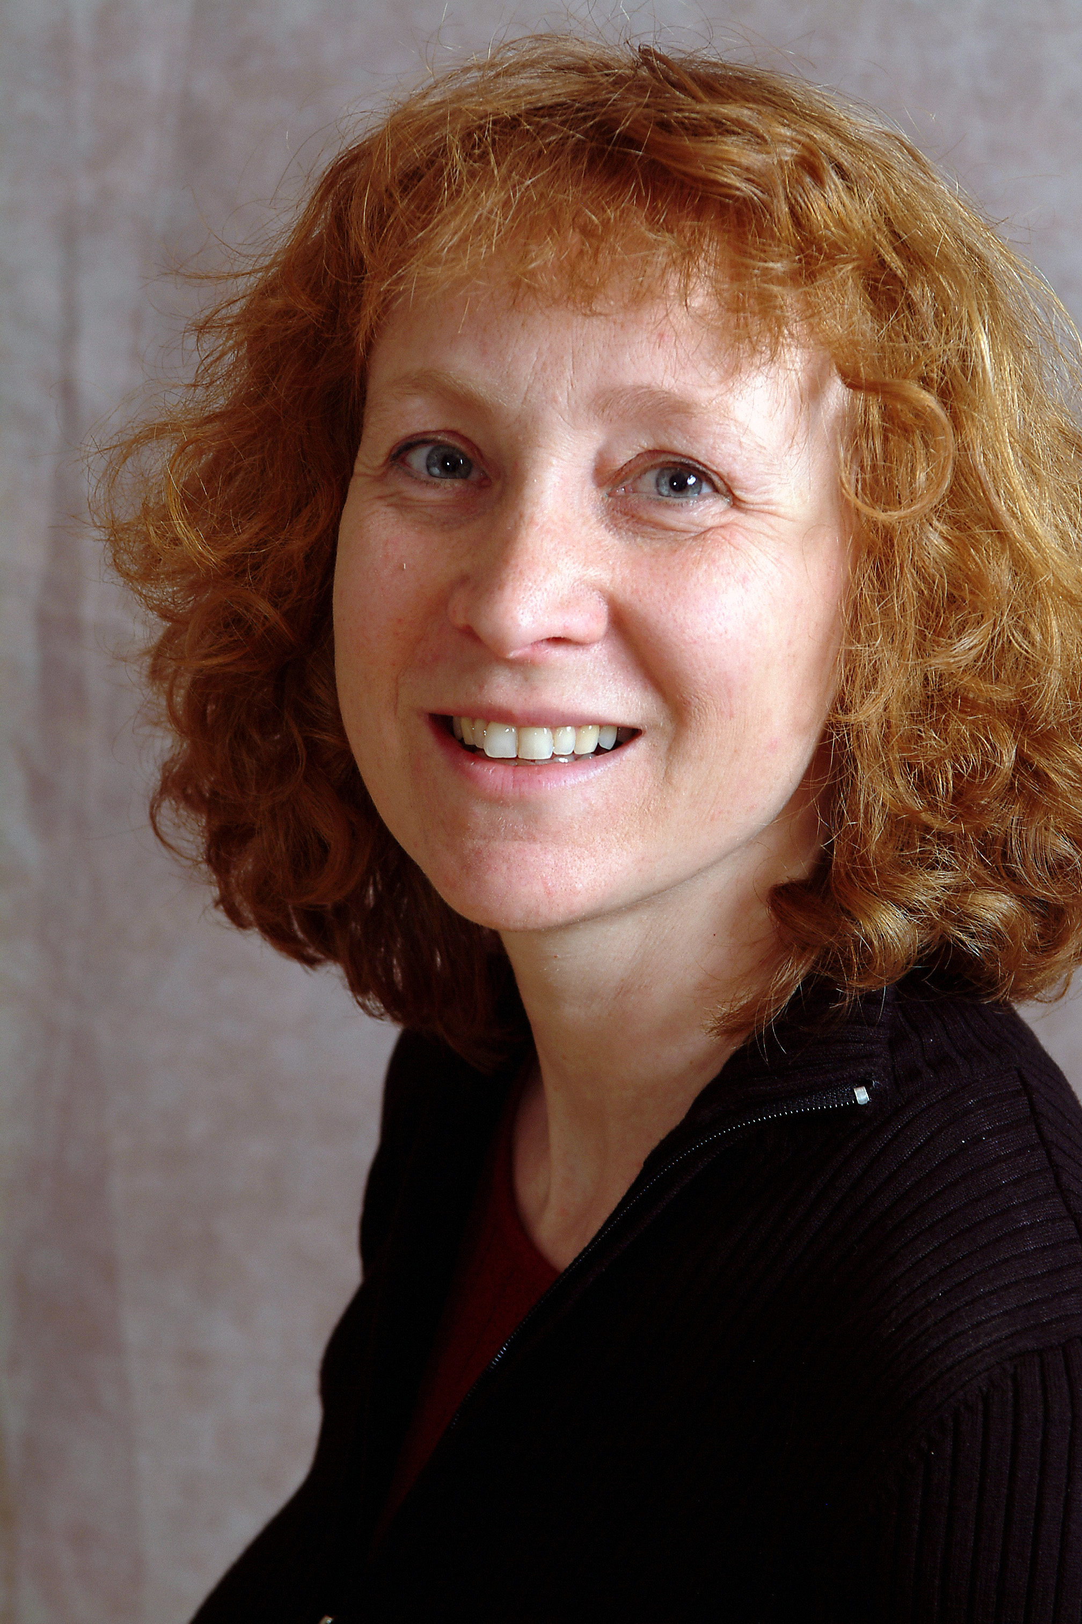

Geneviève Lord Geneviève Lord
Producer

Geneviève Lord was born in Belgium where she completed a degree in Electronics at the same time developed a long lasting taste for dungeon and war games. In 1984, she bought her first Wizardry (PC) and hasn’t stopped playing since!

After completion of a Bachelor of Science in Montreal she started working as a computer consultant in Trinidad. Her 14 years of experience in computer management took here all over the world, (Montreal, Brussels, Stockholm). She worked for companies such as, CN, Beatrice Foods, BCE, Centre de Recherche Informatique de Montreal (CRIM), Continental Bank, Ericsson, Exxon.

She returned to Montreal and obtained her MBA in Information Systems and International Business at McGill University.

For the next 3 years, Geneviève was based in Madrid, where she decided to concentrate on her children’s education. This translated into a lot of mountain climbing and intense Warhammer and PC gaming.

Secure in her managerial and gaming experience, in the summer of 2003, Geneviève joined Ubisoft. She is now the producer of the new Myst episode.

