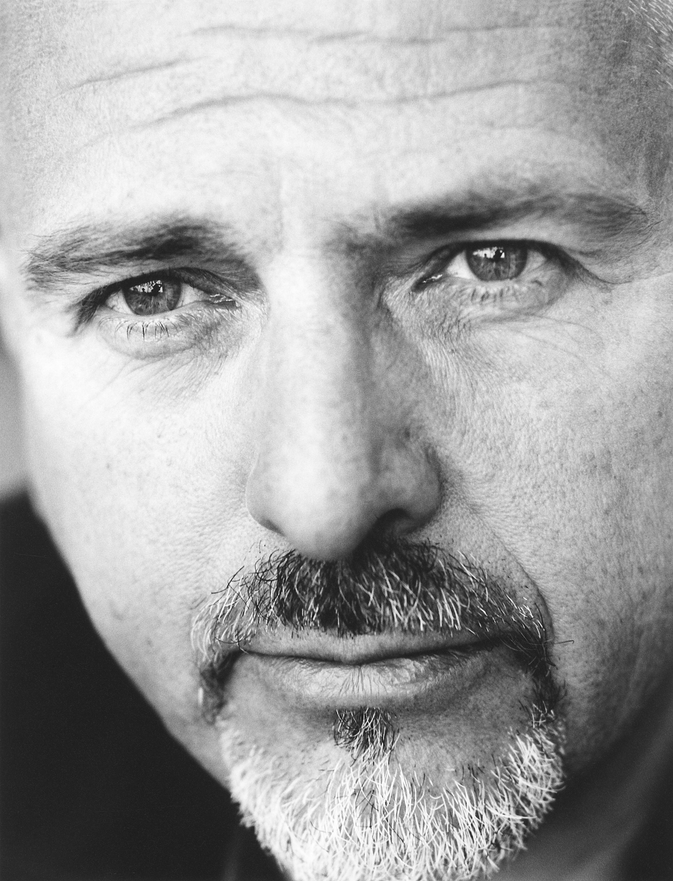

Peter Gabriel
Artist and Producer

Peter Gabriel has earned a worldwide reputation for his innovative work as a musician, writer and video maker. When at school he co-founded the group Genesis, which he left in 1975. His albums, live performance and videos since then have won him a succession of awards. In 1980 he collected a group of people together to found WOMAD (World of Music, Arts and Dance). In a series of international festivals, starting in 1982, WOMAD has brought together traditional and modern music, arts and dance from every corner of the globe. In 1993 WOMAD joined Gabriel’s group of companies, based next to Real World Studios.

Gabriel has released eleven solo albums and in 1986, his album ‘So’ won him his first Grammy. The videos from this project confirmed him as a leader in video production and included ‘Sledgehammer’, which has won the most music video awards ever, including number one position in ‘Rolling Stones’ top 100 videos of all time and the MTV most played video of all time. Shortly afterwards he established Real World Studios in Wiltshire, designed as an ideal environment for performance. It also became the base for Real World Records, a label which is dedicated to recording and promoting a wide range of different artists from all over the world.

In addition, Gabriel has been involved in a wide spectrum of human rights and environmental issues. His song ‘Biko’ was the first pop song which talked about the effects of apartheid, and in 1988 and 1990 he was involved in the Nelson Mandela concerts at Wembley. In 1988 he worked with Amnesty International to set up the Human Rights Now! tour, and toured many countries with Sting, Bruce Springsteen, Tracey Chapman and Youssou N’Dour.

Following this, Gabriel co-founded WITNESS (www.witness.org), which was launched in 1992 in conjunction with the Reebok Human Rights Foundation and The Lawyers Committee for Human Rights in the USA. The organisation arms human rights activists from around the world with hand held video cameras, computers and communication technology so they can document and put an end to human rights abuses. To date, WITNESS has supplied hundreds of cameras to over fifty countries, provided video testimony to human rights commissions and international peace-keeping agencies and had its work shown on television stations around the world. WITNESS also broadcasts monthly “Rights Alerts” – powerful video calls to action - on www.witness.org, which receives over 1.3 million hits each month. In 1989 Gabriel visited the USSR to help launch Greenpeace there, and also contributed to the ‘One World, One Voice’ album, a collaborative album, which featured artists from all over the world.

Gabriel was asked by Alan Parker in 1984 to write the score for the film ‘Birdy’, which won the Grand Jury Prize at the Cannes Film Festival. In 1989 he composed the sound track for Martin Scorsese’s epic film ‘The Last Temptation of Christ’ which was the basis for one of his most experimental and innovative albums, ‘Passion’. This album, which involved an extraordinary selection of musicians and singers, tried to integrate many very different styles of music. It was the inspiration behind the BBC’s specialist radio programme, ‘Mixing It’.

For the release of his tenth album, ‘US’, in 1992 he commissioned eleven artists to interpret the individual songs on his album. The individual works of art were featured at the British Contemporary Art exhibition in 1993 and also in a special exhibition in Japan. ‘US’ earned him four Grammy nominations and two MTV Awards in the US and a BRIT and Q Award in the UK. The fourth single, ‘Kiss That Frog’, was the starting point for the creation of the world’s first motion video ride, entitled ‘The Mindblender’. Developed in association with Mega in the US, ‘The Mindblender’ toured the USA and proved to be a popular mix of ride-motion, film and music.

April 1993 was the start of the “Secret World Tour”. Produced by Gabriel and pioneering Canadian director/designer, Robert Le Page, the show blended Le Page’s visionary style of theatre with personal songs focused on relationships. It was seen by over a million fans in five continents and toured for eighteen months. In November 1993 the show was filmed and recorded in Modena, Italy by Francois Girard, and in August 1994 “Peter Gabriel Secret World Live”, the double live album and video, was released.

In 1993 Gabriel set up Real World Multi Media and brought together a team of experts dedicated to developing, producing and publishing innovative CD-ROMs and pushing new technology to its limits. RWMM launched a series of multimedia titles, which went on to win many awards across the world, including the coveted Milia d’Or, two BAFTAS, the 1994 BIMA Award, the Sparky from the Interactive Media Festival and four awards at the Digital Media Awards. Among these titles were ‘Ceremony of Innocence’ and Gabriel’s CD-ROMs ‘XPLORA’, ‘EVE’. In 1996 Radio Real World became the official web site focusing on Real World and Gabriel.

At the end of 1997 Gabriel was invited by Mark Fisher to help create a show for the central space of the London Millennium Dome.1998 was spent brainstorming ideas on the narrative and visual concept. In 1999, whilst continuing to be involved with the show’s development, Gabriel composed the music. The show was opened on January 1st 2000. An album of this music, entitled OVO, was released on Real World/Virgin Records on June 5th.

In 2000, Gabriel co-founded and became board member of OD2 (Online Distribution), which is now the leading European platform provider for the distribution of on line music.

In 2002 Gabriel completed the soundtrack to Philip Noyce’s film ‘Rabbit Proof Fence’, entitled ‘Long Walk Home’, and released his studio album ‘UP’ on 23rd September 2002. Following the release of ‘UP’, Gabriel worked on his ‘Growing Up’ tour, again collaborating with the theatrical director Robert Lepage. The tour took him to the USA and through Europe, finishing in June 2003. In November 2003 a DVD of the ‘Growing UP’ tour released, and also a compilation album ‘Hit’.

Currently, Gabriel is taking his show ‘Still Growing Up’ around Europe. The tour started at the end of April and finishes in July.

